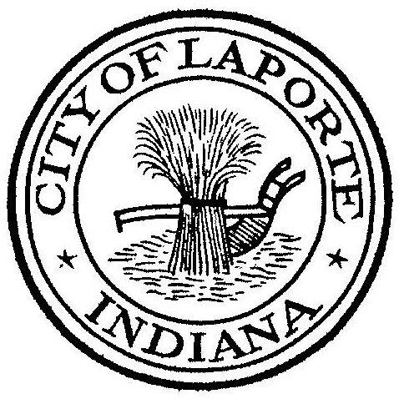
Board of Public Works and Safety
Jessica Romine, Member Tom Dermody, Mayor Mark Kosior, Member
City Hall 801 Michigan Ave., La Porte, IN 46350
Friday, February 25, 2022
2:00 PM
AGENDA

- Call To Order
- Pledge Of Allegiance
- Public Comment: via Facebook Live
- New Business:
-Award Paving Bid
5) Other Business:
6) Adjourn

